

CAF Adopt Phase - Scenario 1 - SQL Migration - On Prem to Azure Virtual Machine

List of Contents
1. Adopt (Migration) 3
1.1 Overview 3
1.1.1 Assess Workloads 3
1.1.2 Deploy workloads 4
1.1.3 Release Workloads 4
1.2 Assessment 6
1.2.1 Region 8
1.2.2 Migration Toolset 8
1.3 Deployment 11
1.3.1 Compress and Restore 11
1.3.2 Transactional Replication 12
1.3.3 Other Migration Methods Resources 15
1.4 Release 16
1.4.1 Overview 16
1.4.2 Migration Testing 16
1.4.3 Optimization 20
1.4.4 Additional Post Migration Validation and Optimization Documents 23
1.5 Additional Resources 23

Adopt (Migration)
Before the beginning of data migration to the cloud, the following assumptions should be made.
- From the Plan, Ready, and Adopt methodologies, the source data should have been identified and separated into workloads which are manageable to migrate through iterations.
- There should be a landing zone prepared with the adequate configurations to receive the incoming data workloads
Microsoft Azure provides various types of Virtual Machine (VM) and have classified them based on the Memory, Storage and Compute types. If you want to create a Virtual machine in Azure Cloud, you first need to check your application and workloads and can select the VM machine based on the available types. Types of Virtual Machine Available in Azure Cloud.
- General purpose
- Compute optimized
- Memory optimized
- Storage optimized
- GPU
- High performance compute

For detailed information of these VM types and sizes:
https://docs.microsoft.com/en-us/azure/virtual-machines/windows/sizes

SQL Server on Azure VMs Supports migration of the following versions of the SQL Server.
- SQL Server 2005
- SQL Server 2008 and SQL Server 2008 R2
- SQL Server 2012 and SQL Server 2012 SP1 CU2
- SQL Server 2014
- SQL Server 2016
- SQL Server 2017

Overview
During each iteration of migrating a workload, there are Three (3) phases which are necessary to maximize performance. This section will specifically discuss the following:
- Assess Workloads
- Deploy workloads
- Release Workloads

Assess Workloads
Make concrete decisions regarding cost, modernization options, and deployment tools. Reassure that any assumptions made during the discovery phase on the data characteristics holds to be true; as well as build on top of those decisions to give the most redefined description about that data.

Deploy workloads
Replicate or improve performance from the source by taking advantage of tools available in the cloud such as:
- Azure Database Migration Services
- Azure Data Migration Assistant

Release Workloads
Once the data workloads has been deployed in the cloud, testing, optimization, and review of the newly deployed workload should be done to ensure the correct data and functionality has been deployed.

Below steps will walk us through the overview of the migration process.
- Consider the maintenance windows that are available to the application and database targeted for migration: If they are critical workloads, they may only be able to go offline for a few minutes at a very specific point in time. Alternatively, a workload may be used for historical reporting purposes and can easily be taken offline most days of the week without impacting end-users. These differences will help decide which migration technique needs to be used.
- Start with low priority databases first: This can help ensure the migration process works and help gauge how long the migration is likely to take when you get to your more critical workloads.
- Fix compatibility issues outlined in Data Migration Assistant: These issues should be fixed during the Transform and Optimize phase, but validate that DMA no longer presents any remaining issues.
- Run a test migration with chosen tool: Before migrating the database, run a test migration of the database to confirm the amount of time the migration will take, and any issues encountered during the migration process.
- Test database for issues: When the test migration completes, perform validation steps to confirm that the data is migrated in full and check for any issues encountered on the Azure SQL platform.
- Repeat issue fixes until the database is fixed: For each issue discovered during testing, find a fix, and then retest. Keep repeating this test-fix cycle until all issues have been found and repaired.
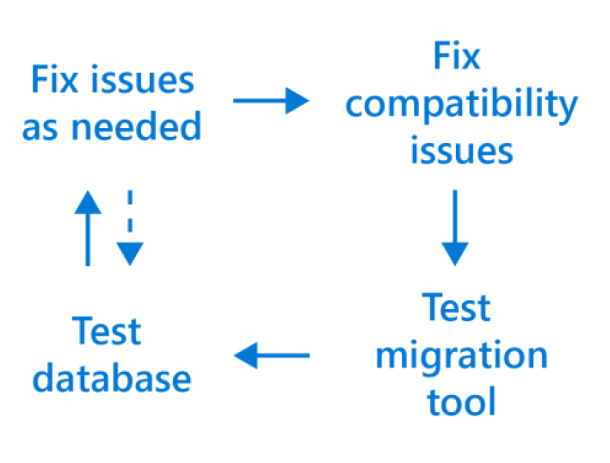
- Re-write third-party applications for the cloud as needed: Third party applications may benefit from the Azure Application Architecture Guide as it discusses older on-premises versus cloud architecture models that could help optimize performance and decrease overhead with leaner coding approaches. Each application should be analyzed on a case by case basis to see if a lift and shift or a re-write in necessary.
- Test third-party applications: Confirm that any third-party applications will still function as expected in the cloud as each application is moved, including any dependencies.
- Take old databases and application offline: Remember to take the source database and application offline before starting the migration process to avoid confusion and preserve the original data in case there is a need to refer to them or perform a roll-back.
- Create new disaster recovery and maintenance plans: Take the time to update your disaster recovery plans, as data has now moved locations and is accessed in a different manner. Consider improving disaster recovery plans by utilizing the geo-replication features of Azure to protect data that may previously have been too complex or costly to protect when on-premises. Maintenance plans will also need to be reviewed as Azure now performs many of those maintenance tasks automatically for you in the background, removing the need to perform them manually.
- Use toolsets to give you greater insight into your environment and greatly assist with the migration process: Numerous Microsoft and third-party tools exist that can help keep tabs on your SQL environments both on premises and in the cloud, including:
  - Azure Database Migration Service (DMS) helps track progress of large-scale migrations of data to Azure.
  - Microsoft Operations Management Suite can help monitor and visualize SQL workloads both on-premises and in the cloud, including SQL Server version count, current CPU performance, job successes and failures, and any logged events.
- Assess migration tools based on disruption to help lower the risk of database downtime: In the coming sections we’ll look at which migration tools require downtime to complete, and which ones can work in the background while the workload remains online and available.
- Understand your workload requirements as a starting point: Requirements might include storage size, storage throughput, and high availability.
- Create a plan to mitigate risk associated with downtime and compatibility issues: Many of the discussed points in this whitepaper will help to reduce the risk of errors during the migration. Conduct test migrations before doing the final migration by getting to know any errors before getting to more critical workloads and have a rollback plan prepared in case of an emergency.
- Understand feature parity between versions of SQL Server and use assessment tools to mitigate choosing the wrong target option: Tools such as Data Migration Assistant (DMA) will help identify if the source workload is using features unavailable on some platforms in Azure.
- Select non-critical workloads for migration initially: This can help ensure the migration process works and help gauge how long the migration is likely to take when you get to your critical workloads.
- Continually iterate on your migration process: During the first migrations small changes will be found, documentation or processes will need to be created, or unnecessary migration steps will need to be removed. These findings should be fed back into the migration process that you are following to optimize the remaining higher priority migrations.

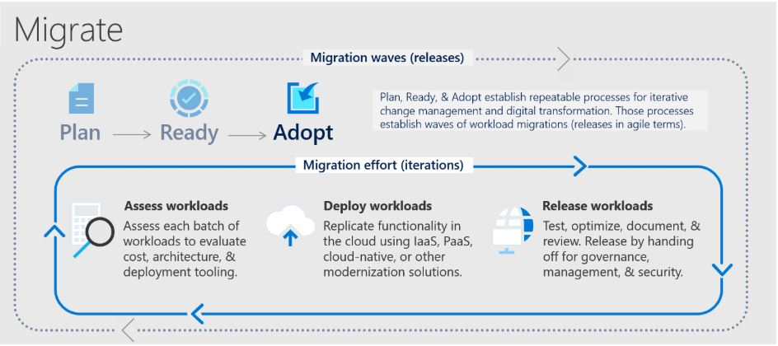

Assessment
Identify existing data sources and details about the features that are being used to get a better understanding of and plan for the migration. First Step is to scan the network to identify all your organization’s SQL instances together with the version and features in use. MAP Toolkit does not require an agent. It automatically inventories the devices, software, users and infrastructure in a Windows or Windows Server deployment and produces a readiness report and proposal for executives with hardware and software information. The data can include metrics such as the number of devices, how many devices run Windows and the number of users. The readiness report can also include information on the applications users work with and if those applications are compatible with the desktop or server operating system IT plans to move to.

When your landing zone for your SQL server data is a Azure VM and the data sources have been identified, the next step is to assess on-premises SQL Server instance(s) migrating to SQL VM’s in Azure to understand the gaps between the source and target instances. To assess the workload native as well as third party assessment tools are as follows:
Assessment Tools | Features | Unique Benefits
Database Migration Assistant | Data Migration Assistant helps pinpoint potential problems blocking migration. It identifies unsupported features, new features that can benefit you after migration, and the right path for database migration. | DMA is able to discover issues that not only disrupt the migration process, but also those that disrupt the on-premises upgrade process for SQL Server. DMA can also discover the new features that are present in the target SQL platform, and will prove to be beneficial for the database, once the upgrade is done.
Azure Migrate: Server Assessment | Discover and assess on-premises VMware VMs, Hyper-V VMs, and physical servers in preparation for migration to Azure. | It can perform assessment in two ways:  - Assessment based on collected performance data  - Assessment based on on-premises sizing
Unifycloud  (Cloud Recon) | CloudRecon creates a cloud migration strategy and assessment by conducting a deep scan on your IT infrastructure, producing recommendations on which applications should migrate to the Cloud (SaaS, IaaS, or PaaS), and the roadmap behind it. CloudRecon is capable of providing TCO estimates and can validate the move to the cloud. | Automated on-premise infrastructure assessments in minutes, not months.  Automation saves time and expense over arduous manual assessments.  Detailed inventory assessments provide insights to inform your cloud migration strategy.
Cloud Amize | Cloudamize is a cloud computing analytics platform that provides high precision analytics and powerful automation to improve the ease, speed, and accuracy of moving to the cloud. | Cloudamize’s discovery, integrated compatibility reporting, right-sizing, and performance and cost predictions enable customers to understand where SQL updates are required and whether it’s better from a cost-performance optimization standpoint to take the IaaS or PaaS version of SQL migration.

An overview of the steps associated with using DMA to create an assessment follows.
- Open the Data Migration Assistant (DMA), and then begin creating a new assessment project.
- Specify a project name, select SQL Server as the source server type, and then select Azure SQL VM as the target server type.
- Select the type(s) of assessment reports (database compatibility and feature parity) that you want to generate.
  - The SQL Server feature parity category provides a comprehensive set of recommendations, alternative approaches available in Azure, and mitigating steps to help you plan the effort into your migration projects.
- Specify the source connection details for your SQL Server, connect to the source database, and then start the assessment.
- When the process is complete, review the assessment reports for migration blocking issues and feature parity issues by selecting the specific options.
- Determine the database compatibility level that you want to minimize your efforts after migrating to Azure SQL Database.

For additional detail on this process, see the article Perform a SQL Server migration assessment with Data Migration Assistant. There are also additional target decisions that you will have to make before starting migration phase. Some things worth taking into consideration are:
- In which region you want your target Azure SQL server
- How much downtime is acceptable for your business needs?
We have provided more details in the following segments.

Region
Azure SQL Databases can be created in multiple regions around the globe. The below diagram shows the regions available in North America.
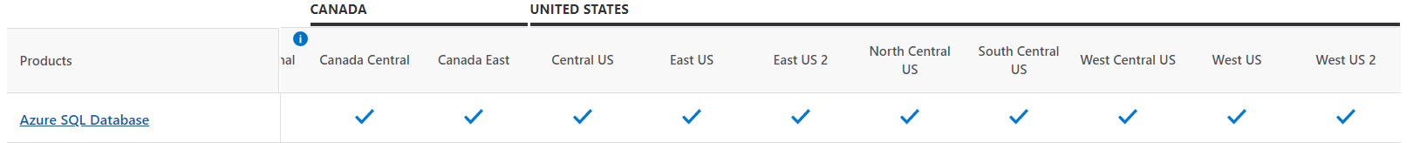
It's always best practice to keep the source and target in the same data centers or at least in the same region to keep latency low and increase the performance during migration. For High Availability (HA) of Azure SQL Database, multi-region deployment is one of the techniques which uses Azure Traffic Manager to failover if the DB fails in one region.
In such a scenario, combined SLA for multiple regions can be calculated as follows.

Let N be the SLA for SQL Database in one region and R be the number of regions where SQL Database is deployed. Combined SLA can be given as = 1 - (Product of Downtime of every region)

Let’s say N = 99.95% for all regions. so, the downtime for all regions will be 0.05%
Combined SLA for 2 regions = (1 - (0.0005 ^ 2)) = 99.999975%
Combined SLA for 4 regions = (1 - (0.0005 ^ 2)) = 99.999999%
So, when we have more regions Combined SLA will increase. Below are the combination of Azure SQL DB deployments option and their promised SLAs.
SLA | Tier | Requirements
99.995% | Business Critical + Premium | Zone Redundant Deployment
99.99% | Business Critical + Premium | N/A
99.99% | General Purpose, Standard, Basic, Hyperscale | 2 or more replicas
99.99% | Hyperscale | 0 replicas

Consider checking Latency before performing multi-region deployment using below links:
- https://cloudpingtest.com/azure
- https://www.azurespeed.com/Azure/Latency

Migration Toolset
There are multiple ways to migrate from on-premises SQL server to an Azure Virtual Machine. Some of the things that need to be considered are.
- SQL Server version
- Whether you can compress your database to a file that is maximum 1 TB
- Downtime acceptability
- If you would like to use your own SQL Server license
- If you have an Always-On SQL Server deployment

There are number of tools and methods that will help you migrate to Azure SQL DB from SQL Server on-premises. Here is a simple workflow that can help with tool selection:
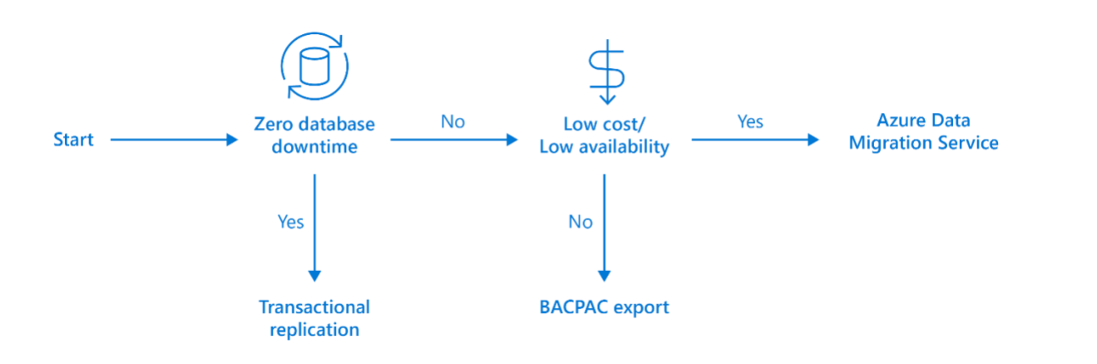
For critical workloads, which can afford zero database downtime, SQL Server Transactional Replication should be used to synchronize all data between on-premises and Azure while keeping the source database online and servicing requests. For general workloads, where small amounts of downtime are acceptable, Azure Data Migration Service can be used to manage the migration process for all these databases.

For all other workloads that can be taken offline at a scheduled time, exporting a BACPAC file containing the data and schema of the source data base and importing this into Azure would be a good fit. Different tools can be used for different needs and no single tool must be used for all database migrations. To get a better glimpse of what are the possible methods and which one best suit your specific needs, following table can be considered:

Migration Methods | Source Version (Min) | Destination Version (Min) | Key Features
On-premises compression and restoration | 2005 | 2005 | - Simplest to implement  - Downtime will be as long as the migration period duration
Convert on-premises machine to Hyper-V VHD | 2005 | 2005 | - Whenever you are bringing your own SQL license and run an older version of SQL  - Migrating both user/system databases dependent which are dependent on another set of user databases  - Great for databases which are larger than
Transactional replication | 2005 | 2005 | - Minimal downtime for large databases. Use if Always-on deployment is not available. Critical database with small or non-existent maintenance window Large databases (>1TB)
Azure Replica Wizard | 2012 | 2012 | - Minimum downtime  - Old SQL Server versions are incompatible  - Must have Always-On on-premises deployment
Backup and restore from URL | 2012 | 2012 | - For SQL 2016, compressed database limit is 12.8 TB
Ship hard drive | 2005 | 2005 | - Alternative to manual copy to restore method

The following table summarizes the scenarios where each of the migration tools are suited:
Migration Tools | Indicators to look for | Unique Benefits
Database Migration Service (DMS) | Many databases to migrate with moderate maintenance window allowance  Large databases (>1TB) | - Supports moving multiple databases concurrently
Move on-premises Hyper-V VM image containing SQL Server to Azure | Small number of servers to migrate with multiple databases with large maintenance window allowance  Small to medium databases (<1TB) | - Supports moving entire server VM to Azure  - Moves disk and all of the dependencies  - See tutorial here - https://docs.microsoft.com/en-us/azure/virtual-machines/windows/prepare-for-upload-vhd-image
Backup and Restore SQL DB to Azure VM | Small number of large databases to migrate  Large maintenance window | - This technique is simple and well-tested for moving databases across machines.  - For details see - https://docs.microsoft.com/en-us/azure/azure-sql/virtual-machines/windows/migrate-to-vm-from-sql-server#back-up-and-restore
Unifycloud (CloudPilot) | CloudPilot analyze applications at the code level to determine cloud readiness and conduct migrations for Cloud-ready applications. | - Demonstrate how the Cloud can lower the cost.  - Reduce the time and expense to migrate applications to the Cloud.  - Create a standard approach to developing and re-mediating applications to run in the Cloud.  - Provide a standard Cloud controls environment for both development and deployment testing.  - Simple App Data Collection  - Cloud Migration Refinement
Cloudamize | The Cloudamize SQL Migration & Modernization Planner eases and optimizes migrating on-premises server databases to Azure. | - Move workloads to Azure with speed and accuracy and ensure cost-performance optimization at the moment applications migrate.

Azure Database Migration Service gives you the option of migrating offline and online. With offline migration, your application downtime will last for the duration of the migration. On the other hand, with online migration your downtime will be limited to the time to cut over at the end of the migration.

Deployment
As part of this document, we’ll explain the ‘compress and restore’ method as well the ‘transactional replication’ method for migrating on-premises server to Azure Virtual Machine. For all other methods, we’ll provide with the adequate links to use the other migration methods discussed.

Why ‘Compress and Restore’ migration method?
The primary reason for including the ‘compress and restore’ method in this document is because it’s quite easy to follow, the best choice for anyone who is migrating a database small enough to be compressed in 1 TB.

Why ‘transactional replication’ migration method?
On the other hand, the ‘transactional replication’ method is a great option when you cannot compress the database in less than 1 TB, would like to remain online during the migration, don’t already have an Always-on deployment, or would like to migrate into an older version of SQL in the virtual machine.

Compress and Restore
The ‘compress and restore’ method is an easy and efficient method to migrate on-premises SQL Server database to the Azure Virtual Machine. In this method start by compressing the database through a SQL script, connect to Azure Virtual Machine instance via a remote connection, copy the compressed file to the virtual machine, and restore the database onto the virtual machine.

Before the beginning of database backup, SQL account such as ‘sa’ must be logged in with database owner rights to avoid permission failure. Once that is done, following script can be run and can be configured with the desired file location and database name:
-- Insert your database name instead of 'database_name'
BACKUP DATABASE database_name
TO DISK = 'file location\filename.bak'
WITH FORMAT;
GO

Once the Back file has been created, remote connection to the virtual machine need to be created. In order to do so, following steps need to be completed:
- From within server, open ‘Remote Desktop Connection’ from the Windows start menu.
- Enter Azure Virtual Machine’s IP Address.
- Go to the ‘Local Resources’ tab and click on the ‘More’ option.
- Under ‘Drives’ select the drive from where compressed Bak file is stored
- Once logged in to the remote server, file can be found under imported drive. In SQL Server Management Studio, right-click on ‘Databases’ and choose the ‘Restore Database…’ option. It should look like this:
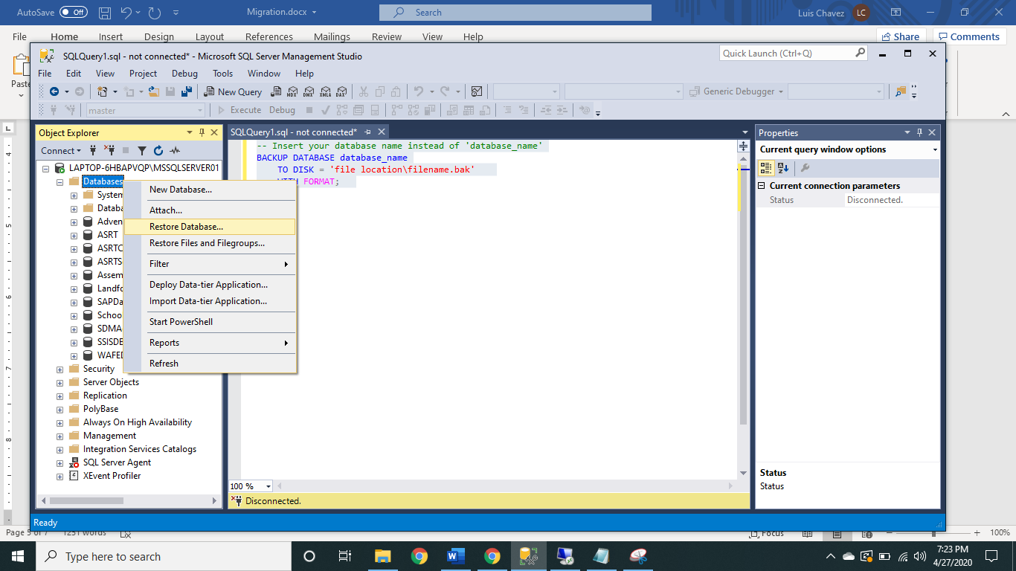
- Next you should select ‘Device’ as the Source.
- Click on the ‘…’ symbol and look for.bak file. The screen should look like this:
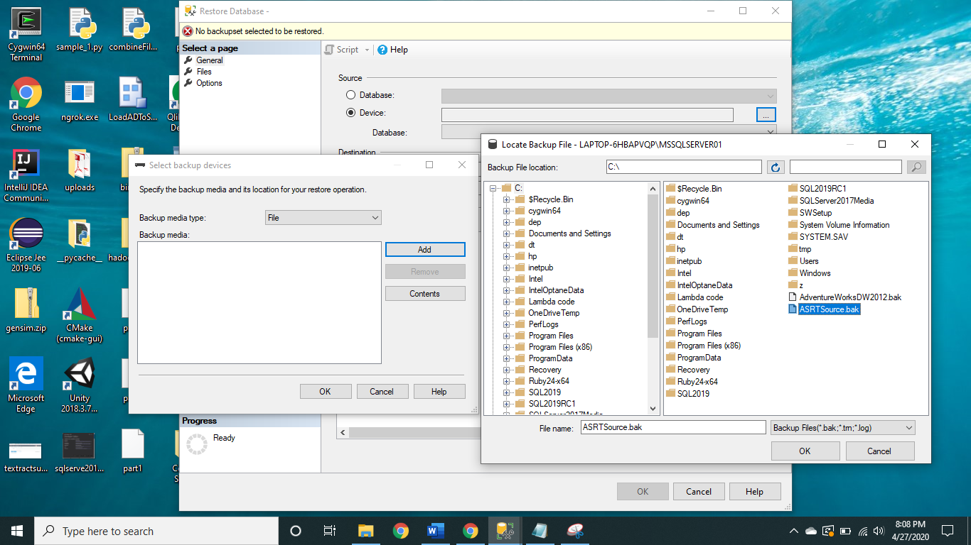
- Press ‘Ok’ and SSMS should begin restoring your database.

Transactional Replication
This method revolves around copying data from one database server to another. This technique follows a master to slave architecture, where the master server sends data to the slave server; and the slave server has to send back a confirmation to the master from where it has received the data. With this approach, we can guarantee that a snapshot of the publication database is maintained. Any changes to the publisher will be reflected at the subscriber’s end with low latency. The major components used in this process are:
- Publisher: A server that sends data to subscriber, maintains publications, and synchronizes publisher and subscriber.
- Distributor: Manages data flow requests within the replication process.
- Subscriber: Maintains data provided by publisher and acknowledges successful deliveries
To create this, there is need to configure publication, distribution and subscription in SQL Server Management Studio.
Configure Distribution
- Log in to SQL Server database as administrator.
- Right-click on Replication and select ‘Configure Distribution…’
- Select the option to have the server be its own distributor.
- For the Snapshot folder, choose to use own network path, or the default path provided.
- Specify Distribution Database name.
- Continue through the Configuration Wizard instructions. Make sure to verify the final configuration display to reflect the specified inputs.
- Press ‘Finish’.
After completion of configuring distribution, publication need to be created. By doing this, we’ll be specifying which database objects we want to migrate and filter other data which we may no longer want.
Creating Publication
- Right-click on Replication à New à click on ‘Publication…’
- Select the database that need to be published.
- Select ‘Transactional Publication’.
- Select the tables that need to be published. (Note that you won’t be able to select any tables which don’t have a primary key.)
- To filter some tables to not include some rows, click the ‘Add…’ option. Here select the table and columns that need to be filtered. To do the filtering own SQL statement need to be written.

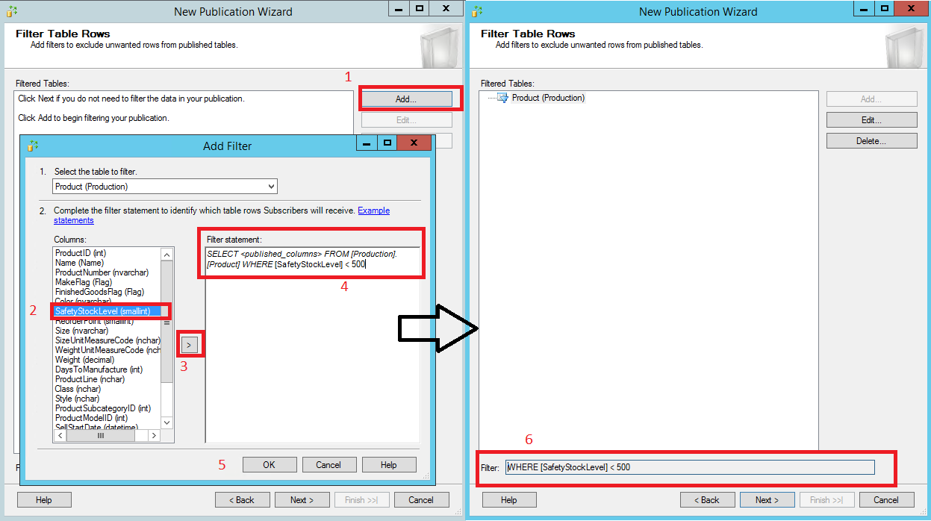
- Select to create the snapshot immediately.
- Click on ‘Security Settings…’. If there is a network domain credentials can be provided here. Otherwise local account name and corresponding credentials can be used.
- Choose the ‘By Impersonating the process account option to connect to the publisher.
- Click ‘Next’ until ‘Complete the Wizard’ window is arrived.
- Enter a publication name. We recommend naming it something such as databaseName: Pub.
- Verify that the configuration matches with the input and click ‘Finish’.
Now that the configured distribution and the publication are created, subscription need to be created. This will allow the SQL Server instance from the Azure Virtual Machine to be setup to begin receiving data.
Creating Subscription
- Connect to SQL server instance from the Azure VM.
- Right-click on ‘Replication’ à New à click on ‘Subscriptions…’
- Click on ‘Next’ to continue to the ‘Publication window.
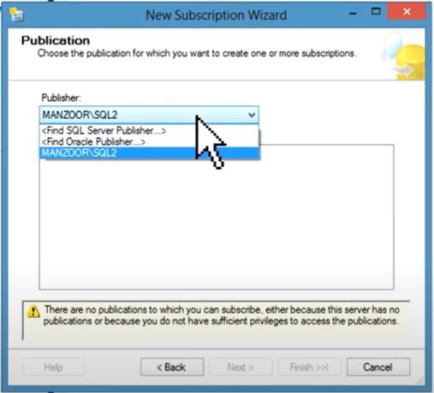
- Select ‘<Find SQL Server Publisher…>’
- Select publisher. You should then be able to see the publisher name you created earlier.
- Select to run agents at the Subscriber.
- Under the ‘Subscription Database’, select the database that is created during the landing zone preparation phase.
- Now give information regarding where the Distribution Agent will run. Click on the ‘…’ symbol and it should pop up a ‘Distribution Agent Security’ window.
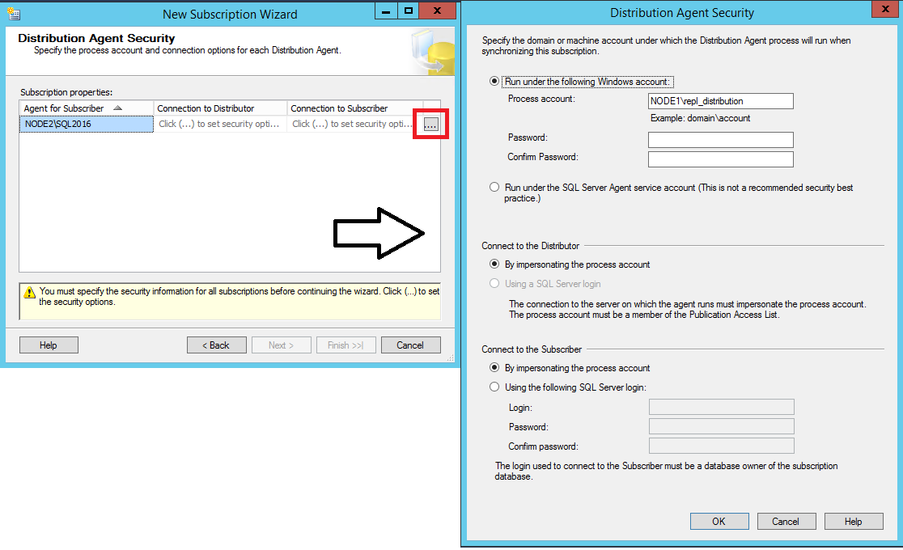
- Give the network account credentials. If you don’t have network credentials, local account credentials can be given
- Make sure the ‘By impersonating the process account’ option is selected for both the ‘Connect to Distributor’ and the ‘Connect to the Subscriber’ sections. Click ‘Next’.
- Select ‘Run continuously’ for the agent schedule.
- Select ‘Immediately’ for the ‘Initialize When’ dropdown selection.
- Click ‘Next’ until the ‘Complete Wizard’ window.
- Verify input is correctly configured and click ‘Finish’.
Once this step is completed, data should begin migrating from source SQL server to your Azure VM SQL instance.
To monitor this process, right-click on ‘Replication’ and select ‘Launch Replication monitor. Here performance, latency, and log details can be seen. More details will be covered in the ‘Release’ section.

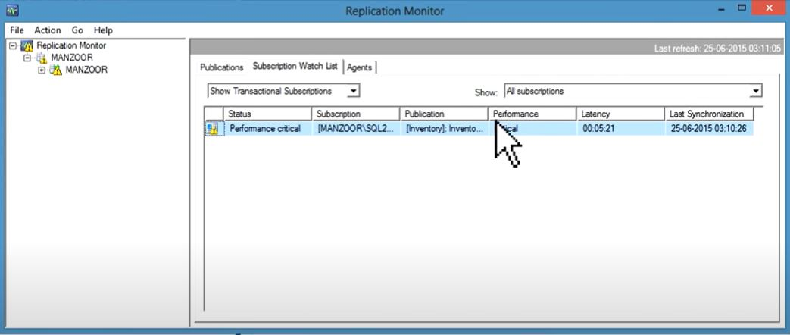

Other Migration Methods Resources
If neither the ‘compress and restore’ or the ‘transactional replication’ migration methods suit the deployment needs; one of the following links can be used to learn more about other migration methods:

Convert on-premises machine to Hyper-V VHD:
- Convert physical or virtual machines to Hyper-V VHDs:
https://www.veeam.com/blog/how-to-convert-physical-machine-hyper-v-virtual-machine-disk2vhd.html
- Upload VHD files to Azure Storage by using the Add-AzureVHD cmdlet:
https://docs.microsoft.com/en-us/previous-versions/azure/dn495173(v=azure.100)?redirectedfrom=MSDN
- Deploy a new virtual machine by using the uploaded VHD.

Release
This section will specifically discuss about the Release phase

Overview
After you have completed migrating, you’re on-premises server into Azure, you need to ensure that the source data is accurately reflected in your new environment. As well as making sure that functionality has been correctly adjusted.

Migration Testing:
There are various technologies that can help you when comparing your source and target database data objects.
The test approach for database migration consists of performing the following activities:
- Develop Validation Tests: To test database migration, you need to use SQL queries. you need to use SQL queries. You must query to run against both the source and target databases.
- Set up test environment: The test environment should contain a copy of the source database and target database. Be sure to isolate the test environment.
- Run Validation tests: Run the validation tests against the source and target, and then analyze the result.
- Run performance tests: Run performance test against the source and the target, and then analyze and compare the results.
In the following sections, we’ll provide specific tools and how to use them to perform migration testing.
- Optimization: Beyond addressing data incompleteness and accuracy, it is necessary to uncover and remediate any performance issues from each workload. As part of this document, we’ll cover some common performance issues that occur from SQL server to SQL server migration and how to address them properly.
- Remediate applications: All client applications which rely on the database must make the correct adjustments to begin consuming data from the newly constructed database. Depending on what are the client applications, the adjustments could be vastly different.

Migration Testing
The objective during the testing phase should be to assess data accuracy in the target database, find incomplete records, and improve performance efficiency. To accomplish this, you could a data comparison tool such as SQL Server Data Tools to perform your data comparison, which we’ll provide details of how to use in the following section.

Additionally, you may have specific data comparison needs that other tools might be more suited for. For that, some third-party tools are discussed later in the section. Using the Database Experimentation Assistant (DEA) to assist with evaluating the target SQL Server on Azure VM environment and to verify that the applications perform well after the migration.
To use DEA for database migration testing, perform the following steps:
- Run a trace capture.
  - On the left navigation tree, select the camera icon the go to All Captures.
  - To start a new capture, select New Capture.
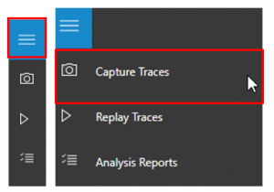
  - To configure the capture, specify the trace name, duration, SQL Server instance name, database name, and the share location for storing the trace file on the computer running SQL Server.
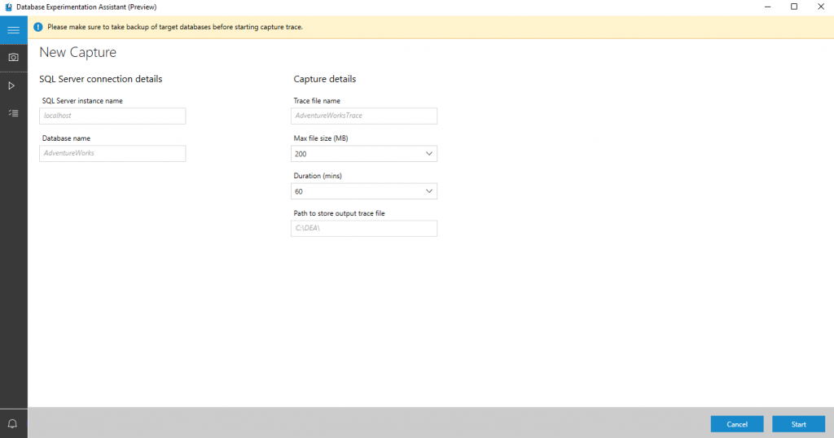
  - Select Start to begin trace capture
- Run a trace replay.
  - On the left navigation tree, select the play icon the go to All Replays.
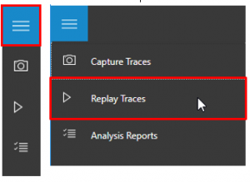
  - To start a new replay, select New Replay.
  - To configure the replay, specify the replay name, controller machine name, path to source trace file on controller, SQL Server instance name, and the path for storing the target trace file on the computer running SQL Server.
  - Select Start to begin replay of your capture.
- Create an analysis report.
  - On the left navigation tree, select the checklist icon to go to Analysis Reports.
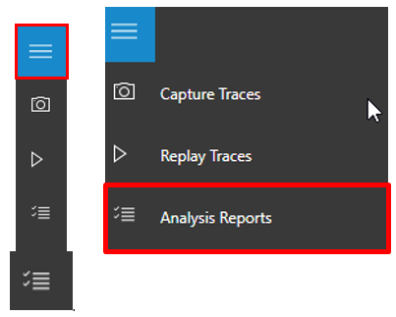
  - Connect to the SQL Server on which you will store your report databases. You will see the list of all reports in the server.
  - Select New Report.
  - To configure the report, specify the report name, and specify paths to the traces for the source and target SQL Server instances.
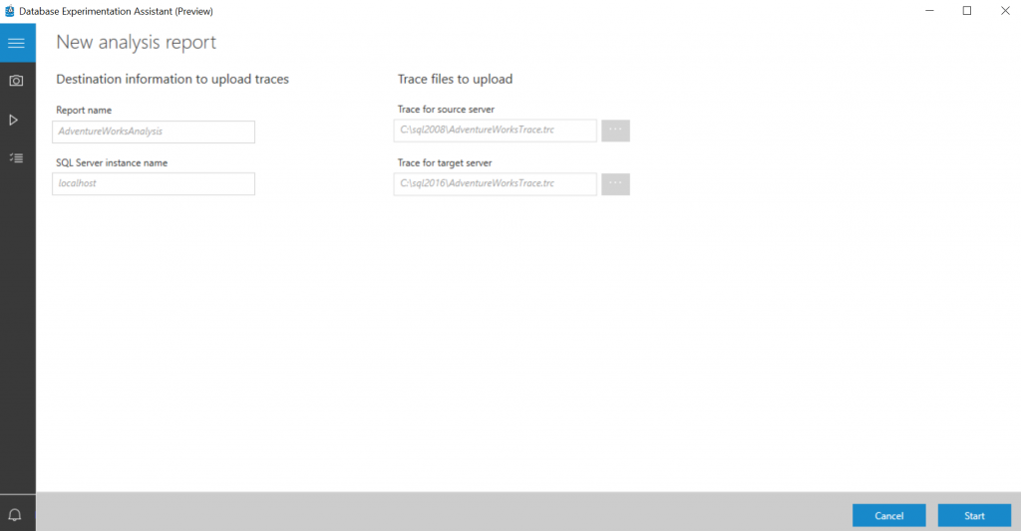

- Review the analysis report.
  - On the first page of the report, the version and build information for the target servers on which the experiment was run displays. Threshold allows you to adjust the sensitivity or tolerance of your A/B Test analysis.
Note: By default, threshold is set to 5%; any performance improvement that is >= 5% is categorized as ‘Improved’. The drop-down selector allows you to evaluate the report using different performance thresholds.
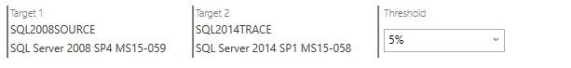
  - Select the individual slices of the pie chart to view drill-down metrics on performance.
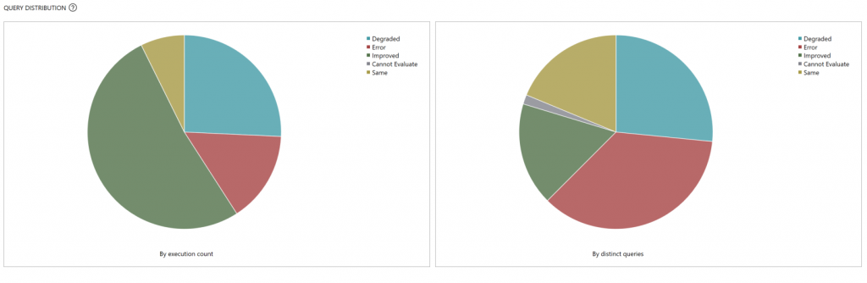
  - On the drill-down page for a performance change category, you will see a list of queries in that category.
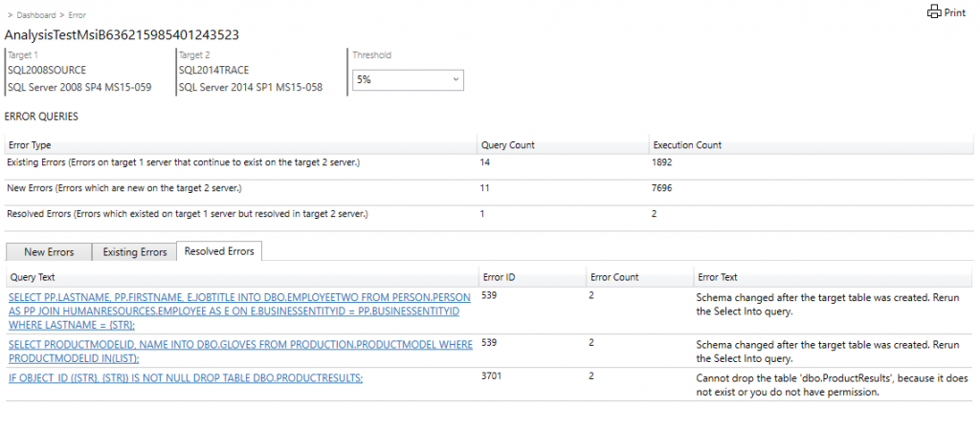
  - Select an individual query to get performance summary statistics, error information, and query plan information.
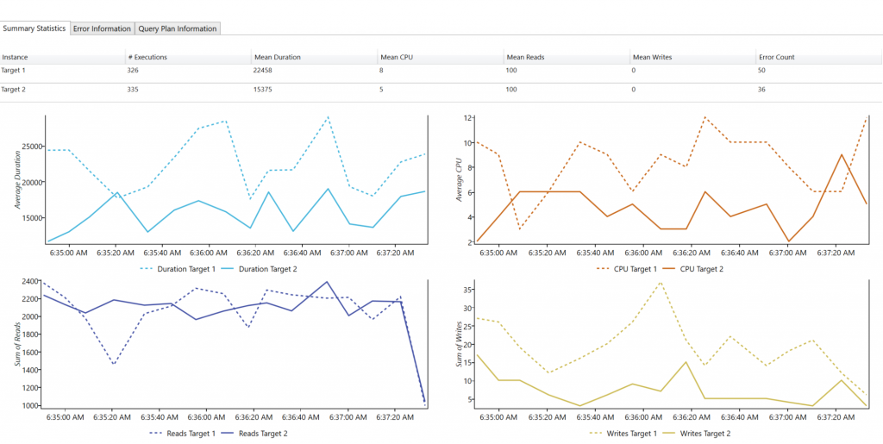

Other Data Comparison Tools
There are other tools that you might want to check out if SQL Server Data Tools does not have a feature you would like to use during your migration assessment. Some third-party tools that can be looked into further are included in the following chart.
Product Name | Operating System | Data Synchronization | Schema Compare | Schema Sync | Free Tier Availability
Query Surge | Windows | Yes | Yes | Yes | No
Red Gate SQL Compare | Windows | Yes | No | No | No
SQL Data Examiner | Windows | Yes | No | No | No
dbForge Data Compare for SQL Server | Windows | Yes | No | No | No
DB Ghost Change Manage Professional | Windows | Yes | Yes | Yes | No
MssqlMerge | Windows | Yes | Yes | Yes | Yes

Optimization
Beyond assessing data accuracy and completeness, you should find any underlying performance issues that might have spawn from your migration. Optimization might include the following steps:
- Assess what new features may be available on the target platform: New features that were previously too complex or cost inhibitive to warrant implementation on-premises may now be available via a few clicks in the Azure Portal. These features should be considered as to whether they would bring good benefits to each workload and then should be implemented as appropriate.
- Re-structure workloads into more cost effective or performance effective sets: This might include allocating databases that make up a workload into various service levels and performance tiers on Azure SQL Database. These were previously lumped together on the same on-premises SQL Server due to hardware and licensing costs, but with the fully managed service offering of Azure SQL Database it’s now cost effective to grant individual databases additional resources if beneficial.
- Ensure workloads are right-sized: Look to realign workloads into the more appropriate service levels and performance tiers. Previously they shared a combined pool of compute and storage resources on the physical server where they resided that was underutilized to allow for future growth. Now with the fully managed service offering of Azure SQL Database it’s possible to get a more accurate size of the databases by using tools such as the Azure SQL Database DTU calculator or comparing on-premises core requirements to vCores and dial up the allocated resources only if required.

Below is some recommendation for best performance during the migration process:
- Choose the highest service level and performance tier that your budget allows for the migration time to maximize the transfer performance: While migrating, the database will be performing an enormous quantity of write operations and by under-sizing the selected performance tier you may unintentionally throttle the throughput, causing a much-extended migration timeline. Instead, choose a higher performance tier than needed temporarily during the migration, and then scale back down after the migration to minimize costs.
- Disable auto-statistics during migration: On Azure SQL Database, statistics objects have “Auto update” turned on by default. The auto update of the statistics is done when a sufficient amount of change to a table has occurred. During the import process, when nearly all the rows in all tables are changing, this trigger is repeatedly met, causing continuous attempts to update the statistics. This update uses valuable IO resources to complete, which detracts from the overall pool of IO resources available for the import process and extends the migration timeline.
- Partition tables and indexes: Partitioning tables and indexes can help with the transfer and access of data during a migration. The data can be partitioned into one or more subsets that are similar and will allow for the transfer of data quicker. Partitioning large datasets can also reduce lock contention, because lock escalation can be activated at the partition level without hurting the entire dataset. Once the data is moved to the cloud, then queries may performance faster and reduce overhead costs for applications. Overall partitioning tables and indexes helps the migration cost and mitigates future risk after the migration by helping increase performance of the data.
- Drop indexed views and recreate them once finished: When an indexed view is used, every time data is modified on an underlying table Azure SQL maintains the index entries on those tables, but also the index entries on the view. This can affect write performance and again reduce IO resources available for the import process, extending the migration timeline. In addition, they also have the potential to cause other issues such as lock contentions.

Below section will cover some common performance issues and how you can debug them.
Query Regressions due to change in CE Version
If you have migrated from a SQL Server version older than 2014 and you have adjusted your database compatibility level to the latest version, there is a high risk that you’ll have performance regression. This is because since SQL Server 2014, all Query Optimizer changes are correlated with the latest database compatibility level. The purpose of this change was to give database users greater control over query performance when performing an upgrade.

You can learn more about this in the following document:
https://docs.microsoft.com/en-us/previousversions/dn673537(v=msdn.10)?redirectedfrom=MSDN

Solution
To resolve this issue, you should first change your database compatibility level back to the source database version and then you can follow the following steps to optimize your query performance:
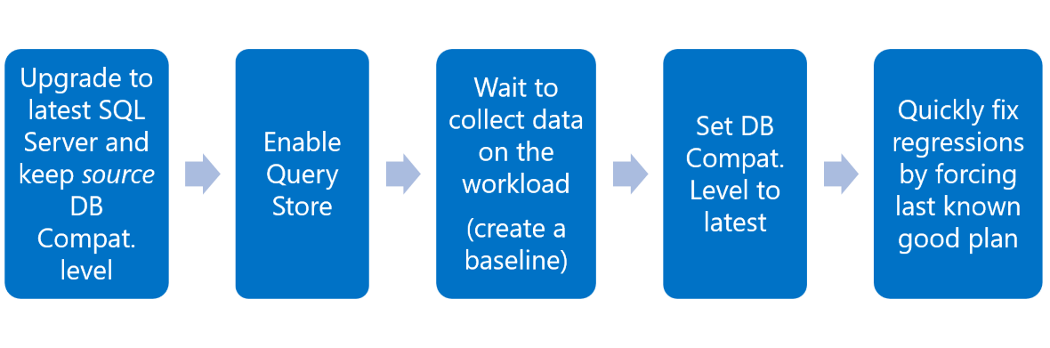
Missing Indexes
When executing queries, stored procedures, and views; SQL performs caching to speed up performance any time the same action is recalled. In the migrated database, this caching of execution plans will not be available at first and will cause execution delays. To minimize this impact, you can follow these steps:
- Use the RECOMPILE hint. A plan is calculated every time adapted to each parameter value.
- Edit your stored procedures to use (OPTIMIZE FOR(<input parameter> = <value>)). Depending on the workload, you will have to choose a value for creating and maintaining one plan that becomes efficient for parameterized values.
- Rewrite the stored procedure using local variable inside the procedure. Now the optimizer uses the density vector for estimations, resulting in the same plan regardless of the parameter value.
- Alternatively, you can edit your stored procedures to use (OPTIMIZE FOR UNKNOWN), which would have the same outcome as using the local variable technique.
- Rewrite your queries to use “DISABLE_PARAMETER_SNIFFING”. This would also have the same effect as using the local variable technique, unless “OPTION(RECOMPILE)”, “WITH RECOMPILE”, or “OPTIMIZE FOR <value>” are used.

Additional Post Migration Validation and Optimization Documents
For additional detail about these issues and specific steps to mitigate them, see the following resources:
- The Post-migration Validation and Optimization Guide.
- Tuning Azure VM

Additional Resources
- SQL migration using Azure Data Migration Service (DMS) hands-on lab.
- Be sure to check out the Azure Total Cost of Ownership (TCO) Calculator to help estimate the cost savings you can realize by migrating your workloads to Azure.
- For a matrix of the Microsoft and third-party services and tools that are available to assist you with various database and data migration scenarios as well as specialty tasks, see the article Service and tools for data migration.
Videos
- For an overview of the Azure Database Migration Guide and the information it contains, see the video How to Use the Database Migration Guide.
- For a walk through of the phases of the migration process and detail about the specific tools and services recommended to perform assessment and migration, see the video Overview of the migration journey and the tools/services recommended for performing assessment and migration.
- For details about the pre-requirements, including Azure VNet and firewall set up, needed to create a DMS instance, see the video How to address pre-requisites and create an instance of the Azure Database Migration Service.
- For information about how to monitor an online migration and perform a migration cutover when the initial load and data sync have completed, see the video How to monitor an online migration and perform migration cutover.

